**AE 211 Group Project**

**Overview:**

The Center for Remote Sensing of Ice Sheets (CReSIS) routinely uses airborne surveys to conduct measurements of ice sheets in polar regions. Your group is tasked with developing a flight planning tool in MATLAB. This tools will be used to determine flight grids, flight times, and GPS coordinates for flight way points for the future planning of missions.

Typical survey flights consist of taking off from an established airfield, flying to the science target, flying a series of parallel flight lines at a prescribed spacing, and then returning home. Figure 1 shows example flight grids from the NASA Operation IceBridge (OIB) that the CReSIS radars support.

**Tool Description:**

The MATLAB tool should be user friendly, and allow the user to specify the location of the airport (start point), the location of the science target, orientation of the flight lines, line length, number of desired lines, and line spacing. Your program will also need the user to specify some information regarding the vehicle to be used for the survey, as these parameters will dictate the grid attributes. The program will also need to check that the limitations of the vehicle are not violated. Use of a GUI is highly recommended

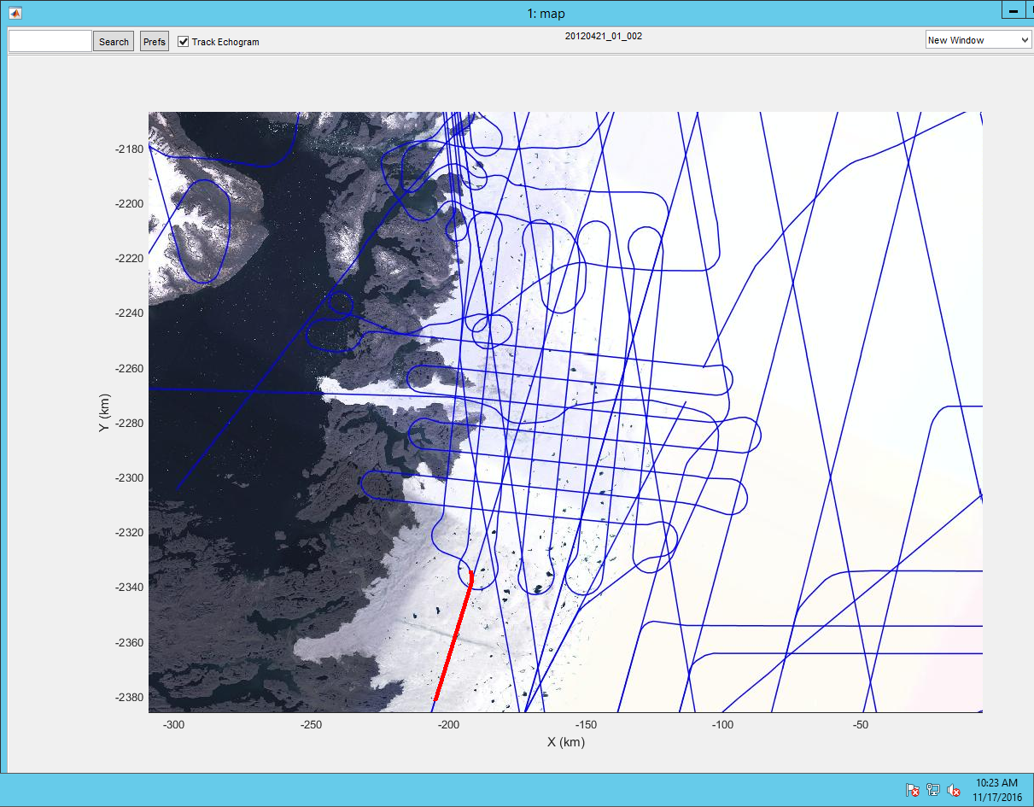

Figure 1: Flight Grid from NASA Operation Ice Bridge

The outputs of the program should include a 2D plot of the flight plan in a Cartesian coordinate system, total distance, and total flight time. The program should also write the GPS way points of the starting and ending points of the flight lines to a text file.

**Deliverables:**

Deliverables for this project will include the program/tool, a professional report documenting the tool, and a 3-5 minute group presentation. **All deliverables are due at 2:00pm on 5 December 2016**. The report should include an introduction, overview of the program (including a block diagram illustrating how the program works), user instructions, an example using the program, program highlights/features, and program limitations. The example documented in the report should assume the mission parameters highlighted in Table 1. This project is worth 150 homework points (~ three homework assignments), of which 100 will be based on the program and 50 will be based on the report and presentation. Peer reviews will also be considered in your individual assessment. There is also a possibility for a 20% “Wow Factor” bonus for up to one group that goes above and beyond in their program design.

Table 1: Example Mission Parameters

|  |  |
| --- | --- |
| **Vehicle** | SIERRA UAS |
| **Starting Point** | Lawrence, KS (39o00'25.26"N, 95o13'09.01"W) |
| **Target** | Columbia, MO (38o55'31.44"N, 92o21'51.83"W) |
| **Line Length** | 5 km |
| **Line Heading** | 60 degrees |
| **No. Lines** | 10 |
| **Line Spacing** | 250 m |
| **Bank Angle Limitation** | 15 degrees |

**APPENDIX A: SPHERICAL GEOMETRY**

The haversine of a central angle, α, for a sphere can be found using:

Where the haversine function is given as:

Recall the formula to find the length of an arc is l=αr, where α is the central angle and r is the radius of the circle. For a point on the Earth, the radius can be assumed to be that of Earth (20902230.9711 ft). Let the distance traveled be, d, therefore the original equation becomes:

where φ is the latitude of the first point (subscript 1) and the second point (subscript 2) and λ is the longitude of the first and second point (subscript 1 and 2, respectively). Therefore, with simple substitution of the haversine formula, it can be shown that the distance between two points on earth can be found as:

The bearing angle is the angle with respect to North to one point as observed from another. If given the lat/lon of two points the bearing angle can be found using:

Where:

Finally given a lat/lon point, bearing, and distance, the new lat/lon point can be found as follows:

Where

Finally, a point on the Earth’s surface can be converted to a Cartesian coordinates using:

where R is the radius of Earth, 20902230.9711 ft

**APPENDIX B: AIRCRAFT CONSIDERATIONS**

Aircraft that are typically used or of interest for surveying are highlighted in the table below

|  |  |  |  |
| --- | --- | --- | --- |
| Vehicle | **SIERRA UAS** | **P-3**  Image result for nasa p3 | **Twin Otter**  Image result for greenland air twin otter |
| Cruise Speed (kts) | 60 | 330 | 110 |
| Range (nmi) | 550 | 3,000 | 850 |

If the velocity and bank angle are specified, an aircraft’s turn radius can be found using the following equation:

For science flights, the bank angle, , is typically limited to 15 degrees due to GPS connectivity. It is also important to keep in mind that the bank angle is typically limited to 30-25 degrees for passenger comfort.

Often times the line spacing specified is less than twice the minimum turn radius of the vehicle. Depending how much less, the aircraft can either turn in the opposite direction for a short time and then make the turn. Or alternating flight lines spaced 2Rmin+S and 2Rmin can be flown. Also measurements can only be taken when the vehicle is in straight and level flight, this means the vehicle doesn’t start its turn until about 15 seconds after the line is finished. Also, it is best to assume the vehicle completes its turn when it reaches a trajectory parallel to the next line.

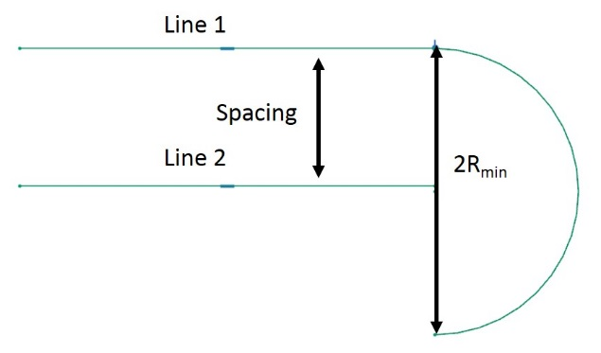

Figure 2: Line Spacing Less than Twice the Minimum Turn Radius

**APPENDIX C: MISSION CONSIDERATIONS**

Below is a table of typical locations CReSIS bases missions out of and nearby science targets.

|  |  |
| --- | --- |
| **Location** | **Possible Science Targets** |
| Thule, Greenland | Multiple tidewater glaciers (ex. Chamberlain), Camp Century, sea ice |
| Ilulissat, Greenland | Jakobshavn Glacier |
| Kangerlussuaq, Greenland | Russel Glacier |
| Nuuk, Greenland | Nuuk Glacier |
| Valdez, AK | Columbia Glacier |
| Barrow, AK | Sea ice |